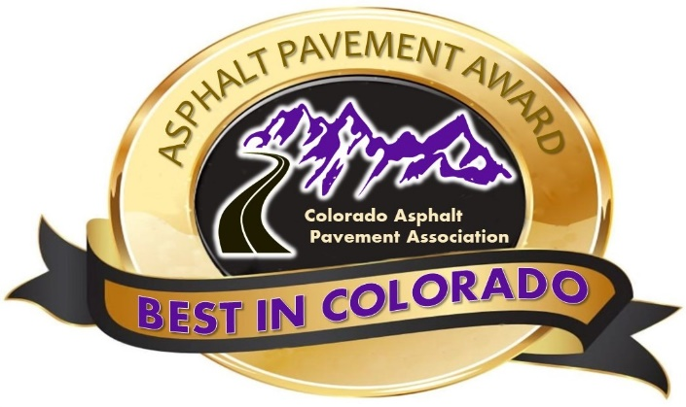

Do you have an exceptional asphalt pavement project that was constructed in 2023? If so, why not submit it for consideration in CAPA’s 30th Annual “Best in Colorado” Asphalt Pavement Awards Program? Award categories include:

Local Agency (City) Local Agency (County)
Urban Highway Rural Highway
Surface Treatment Project Delivery
Commercial Development New Development (Residential)
Sustainability Small Contractor Paving
Airport Special Use Pavement
Golden Oldie

The “Best in Colorado” asphalt pavement awards program is open to all asphalt users, producers, and contractors. Projects nominated for awards can be submitted by the owner/agency and/or the contractor. Nomination forms are available for download on the CAPA website and must be submitted by October 27, 2023.

A panel of judges from Local Agencies and organizations such as APWA, CARSE, ACEC, CDOT, FHWA, review and rate all nominated projects during the months of November and December (weather permitting).

CAPA / CDOT Partnership “Best in Colorado” Awards

Smoothest Asphalt Pavement
Projects in these categories will be judged based on the results of the profile tests summary profile data. The smoothness data will be gathered from CDOT’s project file.
PLANT PRODUCTION
The Plant Production awards are based on data collected by CDOT during production and placement of Asphalt materials for CDOT contracted projects.

If you have questions, please contact Mike Skinner at mikeskinner@co-asphalt.com.

Evaluation Criteria
Overall Appearance
Refers to the uniformity of the materials placed, consistency of appearance, construction quality, texture, workmanship, and the contractor’s attention to detail.
Segregation
Nominations showing segregated areas due to paving operations, raking or broadcasting mix, etc. will be taken into consideration.
Longitudinal Joints
Evaluated as to how straight they are on tangents and smooth their line is on curves. They will also be evaluated on how tight they appear and how noticeable they are. In the Urban and Rural Highways, New or Re-construction and the Re-surfacing Categories, joint density MQL % incentive achieved results will be used as part of the judging criteria.
Transverse joints
Evaluated as to how tight they appear, smoothness across the joint and how noticeable they appear and will be considered for both Ride Quality and Joint Construction.

Ride Quality
Ride Quality will be evaluated as the smoothness of the joint between lanes. Bumps, wheel chatter and must grind areas will also be noted. Transverse joints will be evaluated and considered as part of the Ride Quality judging.

Project Size
The size of a project will be used when considering it for a “Best in Colorado” Asphalt Pavement award. It is important to include quantities in section 5C of the nomination.

Complexity/Difficulty
Impacts influencing the constructability, phasing and overall process of the project will be considered. Elements to be scored include; Night Paving, Traffic Impacts, Number of mobilizations required to complete the project and other on-site considerations.

SCORING
Each criterion will be scored on a scale from 0 to 10 with ten being the highest quality. The scores are then multiplied by a weight factor. The weight given each criterion is based on the significance of what the traveling public will see and feel as well as which criteria has significant effect on the serviceability of the pavement. A maximum of 350 points are possible, projects must score a minimum of 270 points to be eligible to compete for a “Best in Colorado” award.

Criteria Weight Factor
Overall Appearance 7
Segregation 5
Longitudinal Joints 6 (Partially scored using Joint Density MQL Data provided in nomination)
Transverse Joints 3
Ride Quality 6
Complexity/Difficulty Partially pre-scored by CAPA and also judged in the field
Project Size Pre-scored by CAPA based on tonnage placed/SY treated

