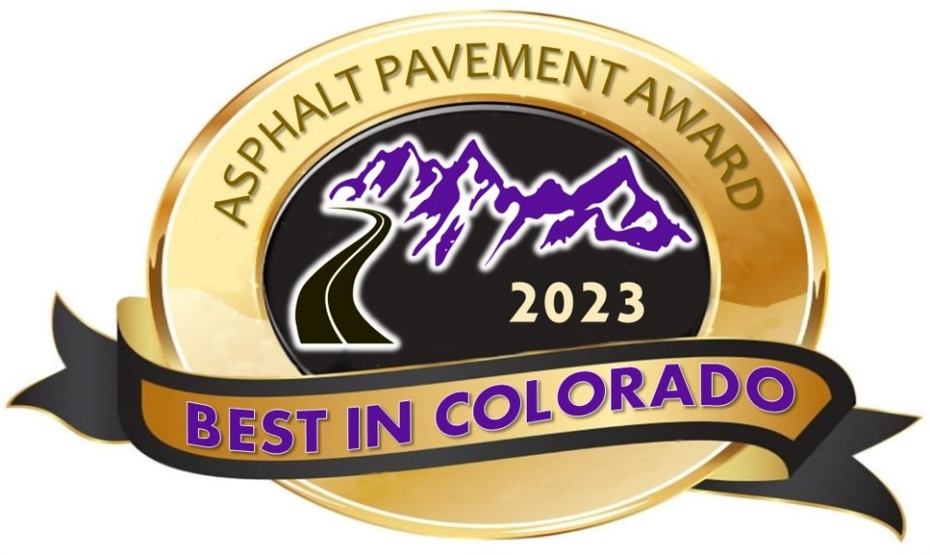
30th Annual

Nomination Form
Digitally Submit Nominations to: Awards@co-asphalt.com
Deadline for submissions is October 27, 2023
Contact Mike Skinner (Award Program Coordinator) with questions at mikeskinner@co-asphalt.com

- submittals are limited to two per company/ agency, per award category.

- any single project is limited to being considered for only one category.

- project location map must be included in the submittal.

- include 4-6 high resolution pictures with your nomination. think about what picture you would like to see displayed in your office if your project is judged to be one of the “best in Colorado”.

LOCAL AGENCY (CITY) (min. 2,500 tons placed)  New or Reconstruction (CIP Projects) OR  Resurfacing (Annual Programs)  Local Agency City projects, choose the best segments to be included in your submittal. All work included in one contract will be part of one project submittal. | URBAN HIGHWAY (min. 5,000 tons placed)  New or Reconstruction OR  Resurfacing (Surface Treatment Program)  All submittals in this category MUST include joint density MQL % incentive achieved results.
LOCAL AGENCY (COUNTY) (min. 2,500 tons placed)  New or Reconstruction (CIP Projects) OR  Resurfacing (Annual Programs)  Local Agency County projects, choose the best segments to be included in your submittal. All work included in one contract will be part of one project submittal. | RURAL HIGHWAY (min. 5,000 tons placed)  New or Reconstruction OR  Resurfacing (Surface Treatment Program)  All submittals in this category MUST include joint density MQL % incentive achieved results.
SURFACE TREATMENT (min. of 25,000 SY placed)  Includes Slurry Seals, Chip Seals, Bond treatments, etc. (excludes Thin Lift overlays.) | COMMERCIAL DEVELOPMENT (min. 500 tons placed)  Parking lots for medium to large commercial buildings and facilities.
SMALL CONTRACTOR PAVING  This category may include but not limited to Parking lots, Trails, Paths, Street paving, etc. for placement contractors without an asphalt production facility. | NEW DEVELOPMENT (RESIDENTIAL) (min. 2,500 tons placed)  Submittals for new residential subdivision roadway construction.
PROJECT DELIVERY  Documentation must be provided to demonstrate successes (e.g., minimizing traffic impacts, reducing project duration, etc.) | AIRPORT  Local municipal to large commercial airports. | GOLDEN OLDIE  30+ year old project still performing with only preventive maintenance.
SUSTAINABIITY  The use of sustainable, innovative and environmentally friendly processes, materials, design or construction to reduce environmental impacts. | SPECIAL USE PAVEMENT  This category may include trails and paths, hydraulic applications, underground facilities, state parks, porous pavements, etc.
SUBMITTALS ARE LIMITED TO TWO PER COMPANY/AGENCY, PER CATEGORY

ALL INFORMATION MUST BE COMPLETED BY CONTRACTOR AND OWNER ON ONE FORM TO BE CONSIDERED
1. Name of Agency/Company Submitting Nomination _________________________________________________________________________________________
Person Making Nomination __________________________________________________________________
Title ____________________________________________________________________________________
Address _________________________________________________________________________________
City ______________________________________________ State _____________ Zip ______________
Phone ___________________________ Email ___________________________________________________
CONCURRENCE of NOMINATION by AGENCY or CONTRACTOR
Name ________________________________________ Title _______________________________________
Organization ______________________________________________________________________________
Signature of Concurrence ____________________________________________________________________

2. PROJECT DESCRIPTION and LOCATION
Project Name/Contract Title ________________________________________________________________
Contract Value $ _________________________________________________________________________
Location (street, highway, projects limits, mile post). Very important that a map and physical directions be included in the submittal. Projects may be excluded if a map is not included: __________________________________________________________________________________________
____________________________________________________________________________________________________________________________________________________________________________________
Description of Project________________________________________________________________________
______________________________________________________________________________________________________________________________________________________________________________________________________________________________________________________________________________
Project Time (# days) ________________________ Contract Time (# days) ___________________________
Start Date _________________________________ End Date ______________________________________
___________________________________________________________________________
Owner’s Acceptance Performed by:
□ Company PC lab □ Contracted PC lab (Name)__________________________________________
4. PAVING CONTRACTOR INFORMATION
Contractor Name___________________________________________________________________________
Contact Name____________________________________________ Title ___________________________
Phone ___________________________ E-mail _________________________________________________
Company Address _________________________________________________________________________
City ______________________________________________________ State _________ Zip __________

3. OWNER/AGENCY INFORMATION
Owner / Agency Name _____________________________________________________________________
Contact Name ______________________________________Title _____________________________
Address _____________________________________________________________________________
City ______________________________________________ State __________ Zip ____________
Phone ______________________ E-mail _________________________________________________

5. PROJECT INFORMATION
A. Asphalt Mixture
No. of lifts ___________
Grading ______________ Binder grade _____________ N_{design} ___________ % Binder ___________
Grading ______________ Binder grade _____________ N_{design} ___________ % Binder ___________
Grading ______________ Binder grade _____________ N_{design} ___________ % Binder ___________
% RAP ______________ Tons of RAP Used ___________________
B. Milling or In-Place Remixing prior to paving □ Yes □ No Type/Depth __________________
C. Project Size
Tons of Asphalt (Total) ________________ OR Surface Treatment (Total SY) __________________
Top Lift (Tons) _____________________
Second Lift (Tons) ___________________
Third Lift (Tons) ____________________

D. Pavement Construction Practices and Other Considerations.
Briefly describe any unique construction features of the project. Include any paving innovations, techniques, or practices that added to the quality or community response to the project. Additional information can be attached. This information must be completed for the Project Delivery Award.
______________________________________________________________________________________

E. Night Paving □ Yes □ No
F. Project Phasing # of Mobilizations for project ___________ # of Phases for project _____________
G. Joint Density MQL (Incentive) Data* Total Incentive achieved %

__
___________________________________________________________________________

*Required for Urban and Rural Highway projects only!
Indicate if this project was completed using:
⃝ HMA, or
⃝ WMA - Process _____________________________
(water foaming, chemical or organic)
6. ADDITIONAL CONTRACTOR (General Contractor, Sub-Contractor)
Additional Contractor Name ________________________________________________________________
Contact Name _______________________________________ Title ___________________________
Address ____________________________________________________________________________
City ___________________________________________________ State _________ Zip ________
Phone ______________________ E-mail ________________________________________________
Additional Contractor Name _______________________________________________________________
Contact Name _______________________________________ Title ___________________________
Address ____________________________________________________________________________
City ___________________________________________________ State _________ Zip _________
Phone ______________________ E-mail _________________________________________________
9. PHOTOGRAPHS (Required)
High Resolution photographs must be submitted in a digital format.
Provide the best, high resolution pictures you can get. Submit a minimum of 4 to 6 pictures in your nomination packets. Think about what picture you would like to see displayed in your office if your project is judged to be one of the "Best in Colorado".

8. SIGNIFICANT CONTRIBUTERS
This Partner made significant contributions to the overall success of the project. (e.g., Rubblization, FDR, Milling, Stripping, etc.) Please describe the contribution made by the subcontractor. (This area may be left blank if no subcontractor needs to be recognized for their contributions to the project).

7. Design & Materials Selection (Engineer, etc.)
Identify additional Partner(s) or Firms involved in the design, materials selection or project delivery who contributed to the success of this project. (This area may be left blank if no additional partners need to be recognized for their contributions to the project).

